Roll Number : 22P31A4244

Name : TADI V V DURGA HARI PRASAD REDDY

1.Take a screenshot of partitions information in your laptop and paste here

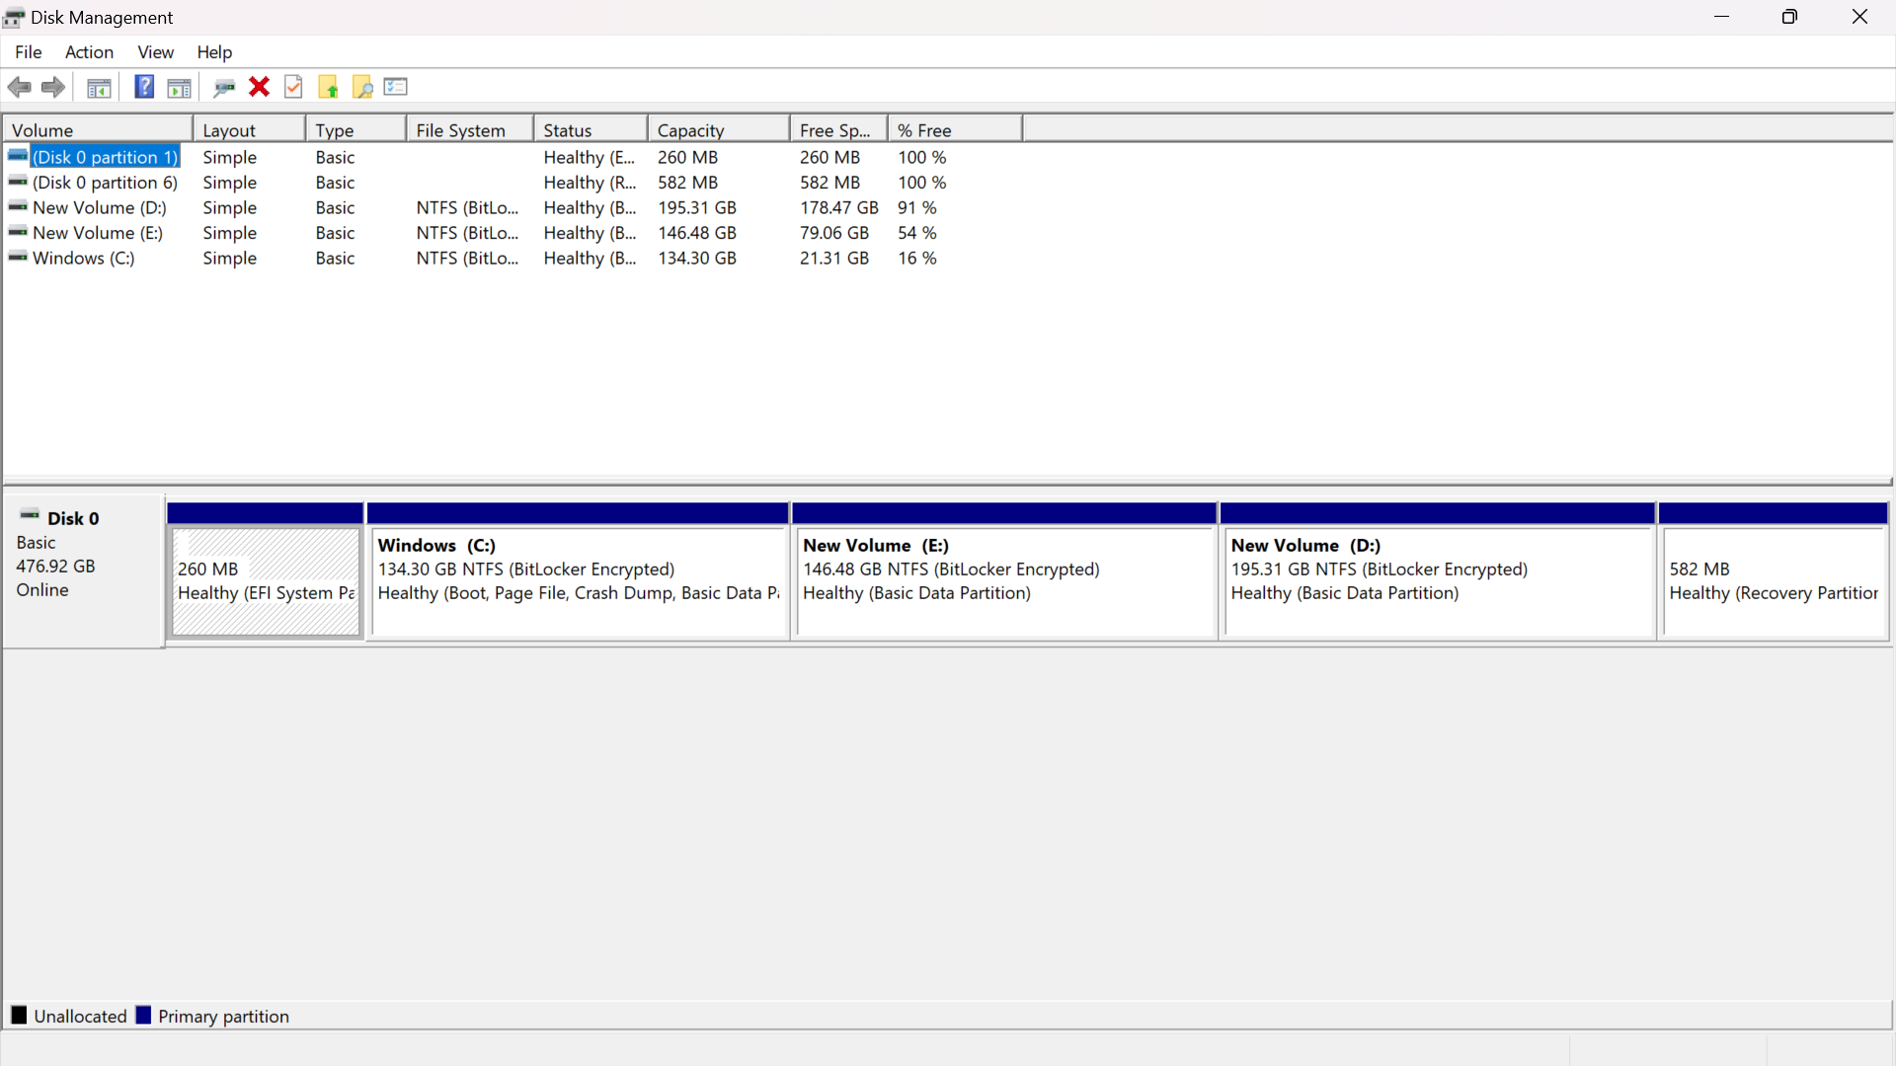

2. Post the screenshot of memory and CPU usage of Microsoft word running in your laptop

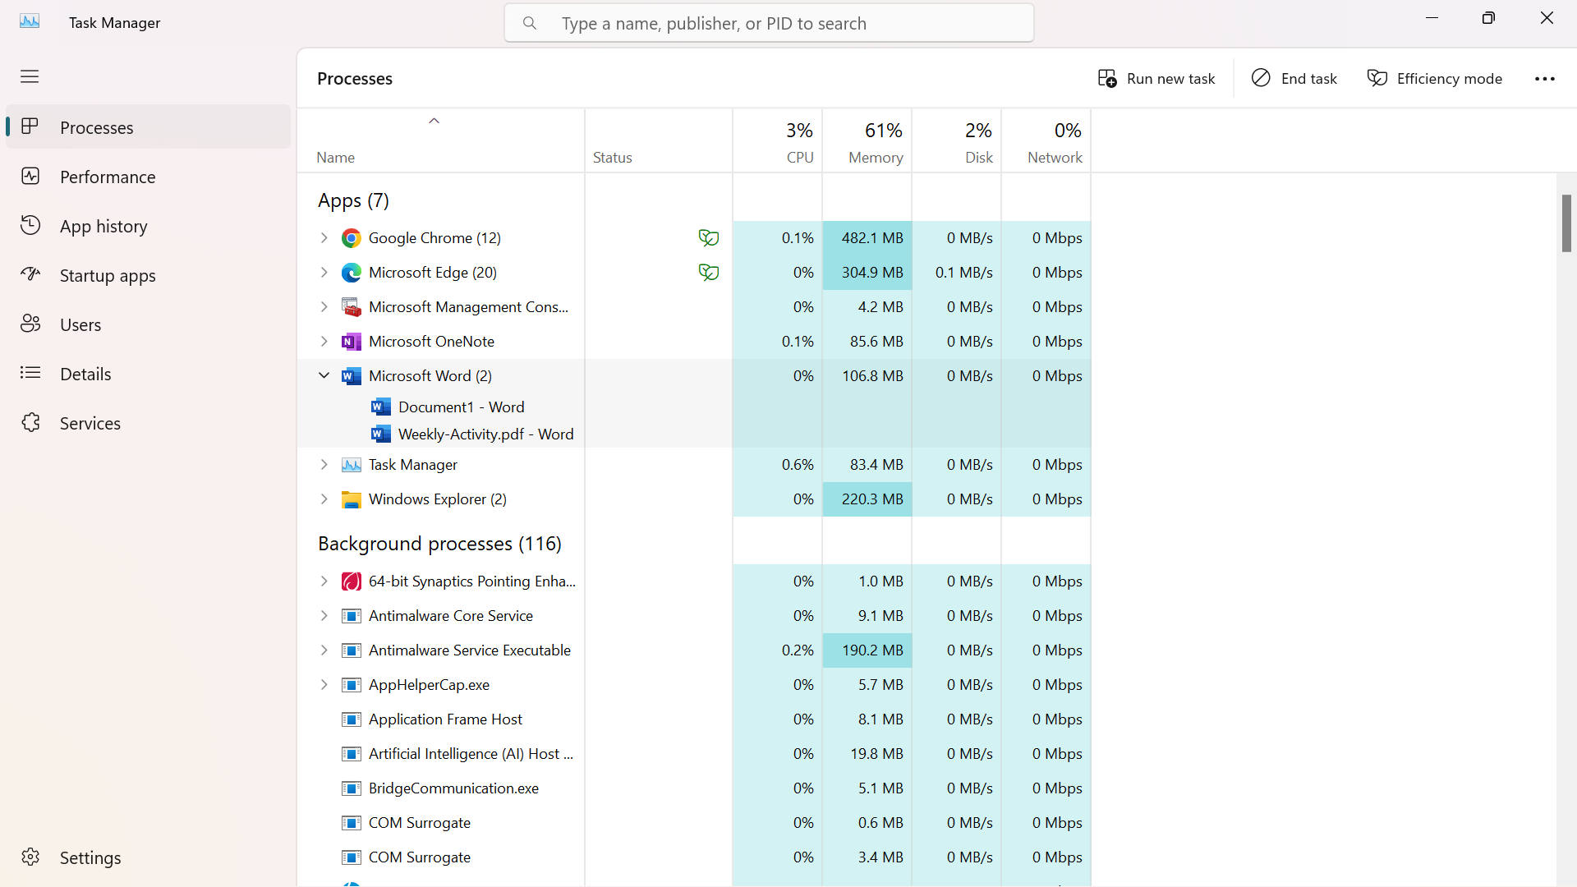

3. What the name of hypervisor mentioned in below picture

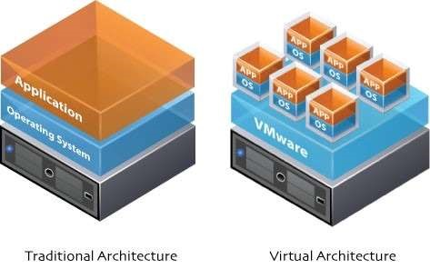

1. VMware hypervisor

4. One IT company maintains a Dell Power Edge rack server with below configuration:

• 256 GB RAM

• Intel Xeon processor with 50 cores

• 10 TB SSD

The company requirement is to accommodate 20000 users to the application and system administrator is tasked to create servers to accordingly. The users per server should not be more than 2000 assuming that 10GB of RAM supports 1000 concurrent users.

If you are the system administrator of the company, what will you suggest for following:

1. How many no.of VMs to be created .?
2. 10
3. What would the configuration of VMs that you create .?
4. 20GB
5. Which Operating System do you suggest for servers .?
6. 5 CORES
7. What would you suggest to maintain High Availability of application that runs on this server .?
8. 1TB

5. Scenario: Setting up a new application infrastructure Imagine you're part of a team tasked with setting up a new web application for a growing ecommerce company. The application is expected to handle a large number of concurrent users and process a significant amount of data for transactions. As a crucial first step, you need to determine the optimal server characteristics to ensure the application runs smoothly and efficiently. Hence, point out server characteristics that are essential to maintain the same.

A. use cloud computing

6.Provide the screenshot of no.of AWS regions and Availability Zones as of the day

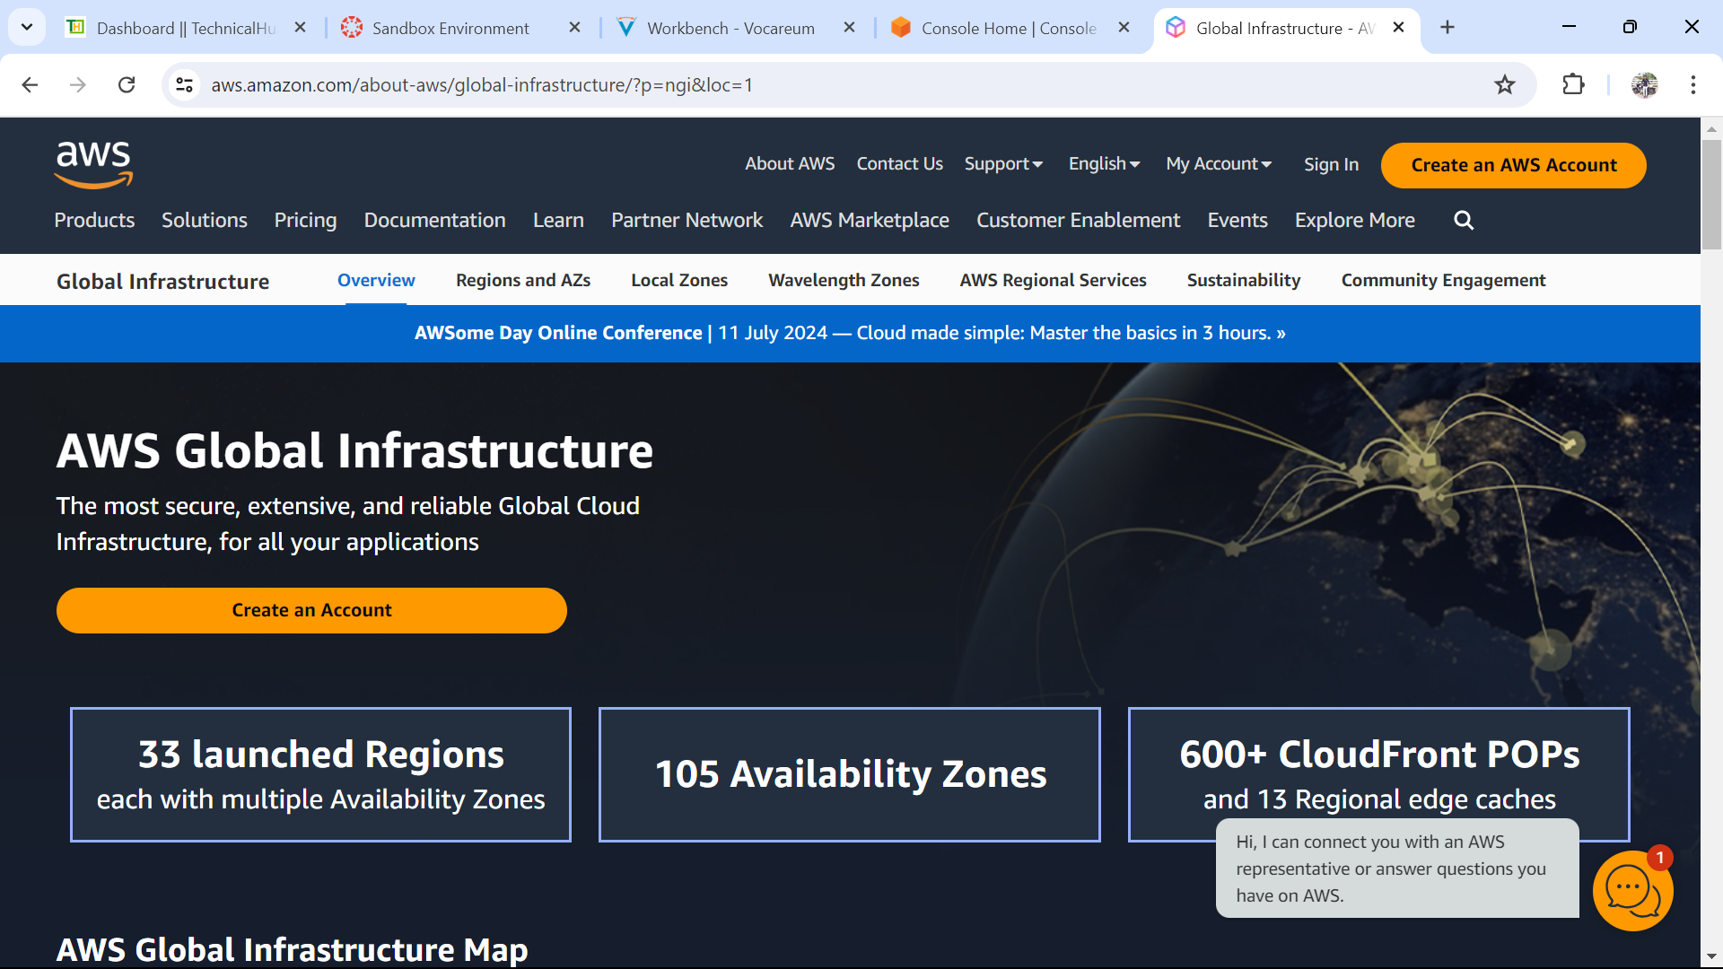

7. Provide the screen shot of Availability Zones in N.Virginia region

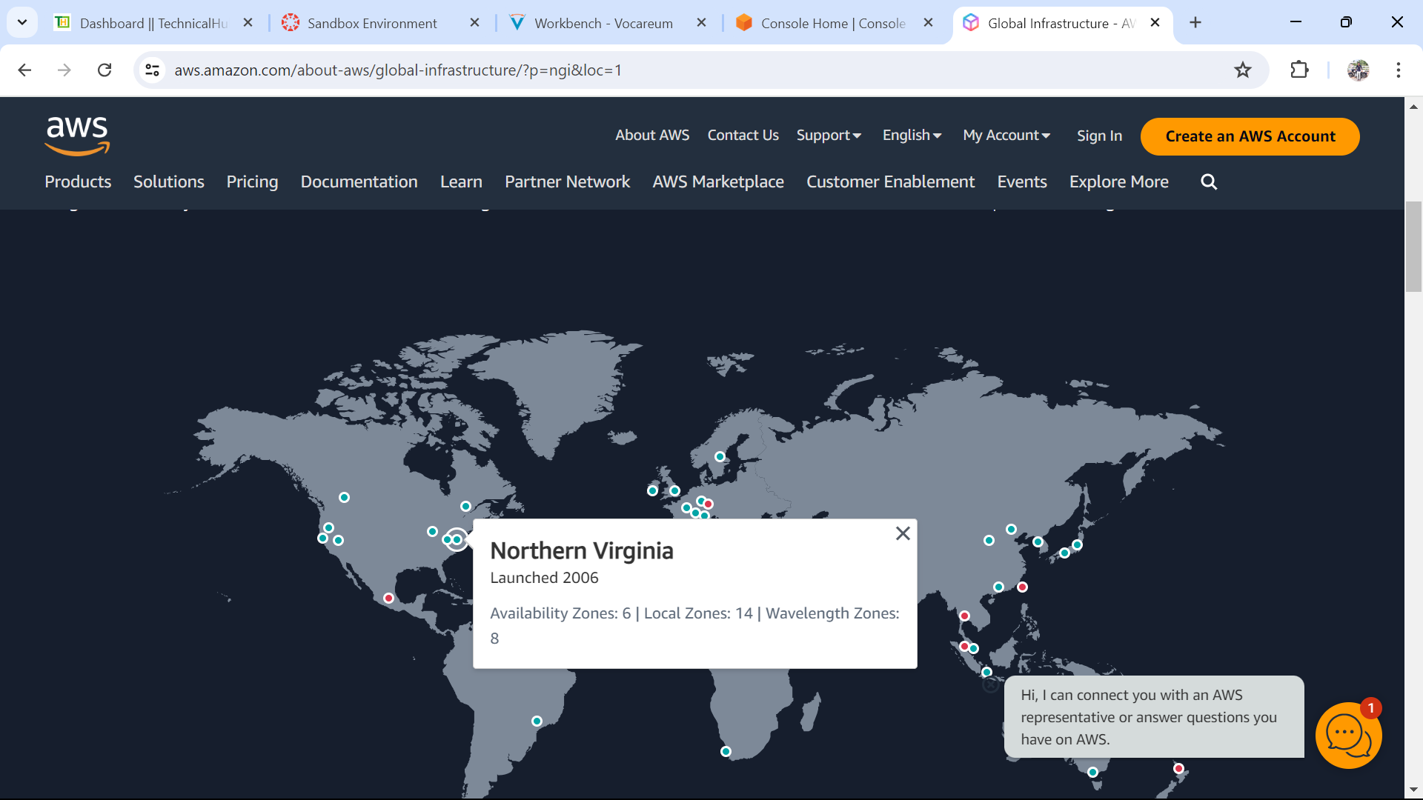

8. Draw the sample region of AWS Global infrastructure hierarchy in MS Paint and provide screenshot here

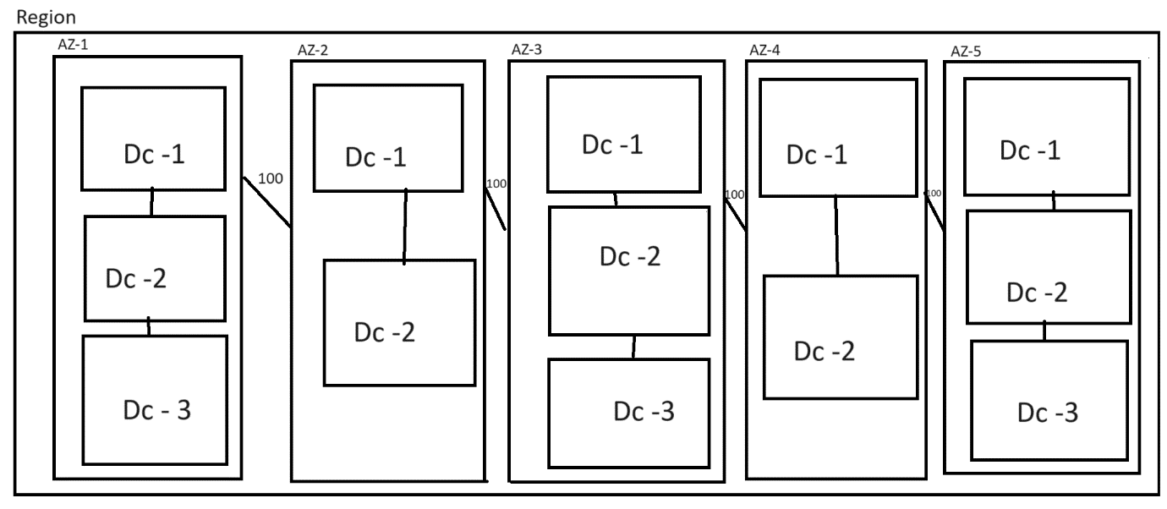

9. Launch the ubuntu VM with following configuration

a. Ubuntu latest version

b. Free tier t2 type VM

c. us-east-1f availability zone

d. download pem format key file

e. user data should contain following line in webpage

Hi, this is and welcome to Technical Hub Drive ready-2026

Provide the screenshot of userdata and launched webpage.

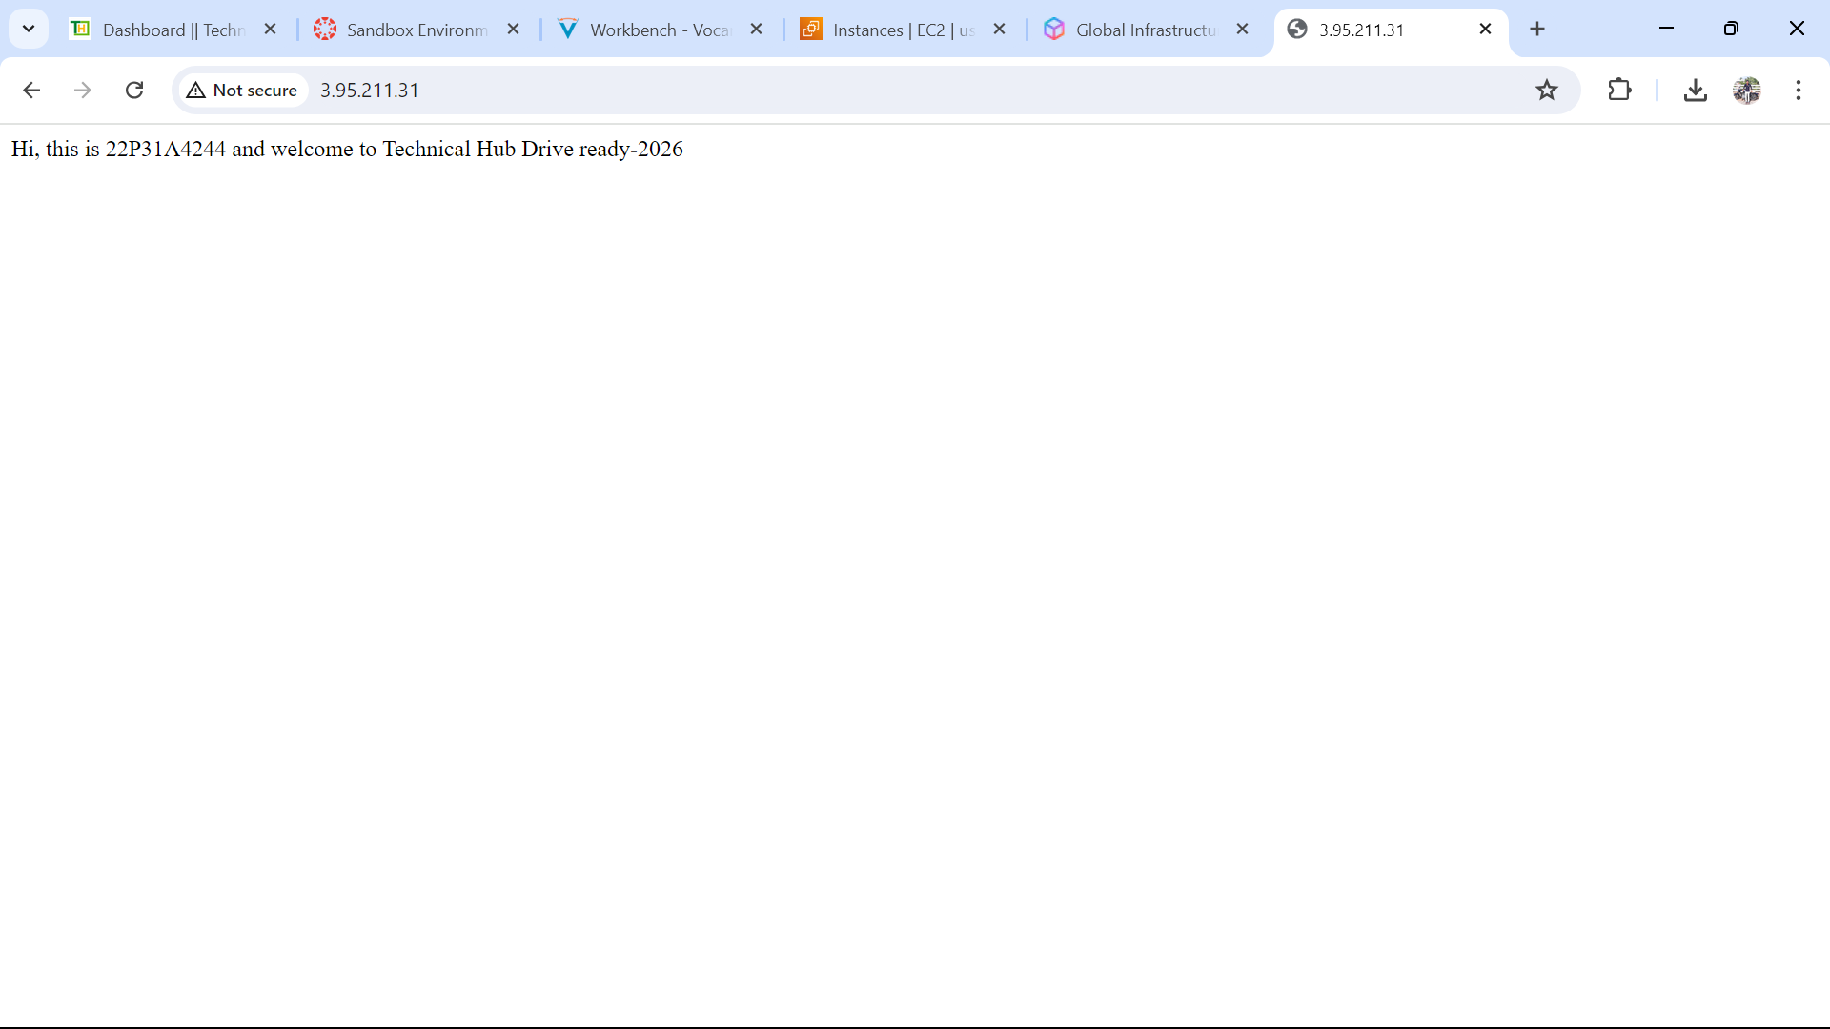

10. Connect to the same linux VM from windows command mode (not from mobaXterm) and provide the screen shot

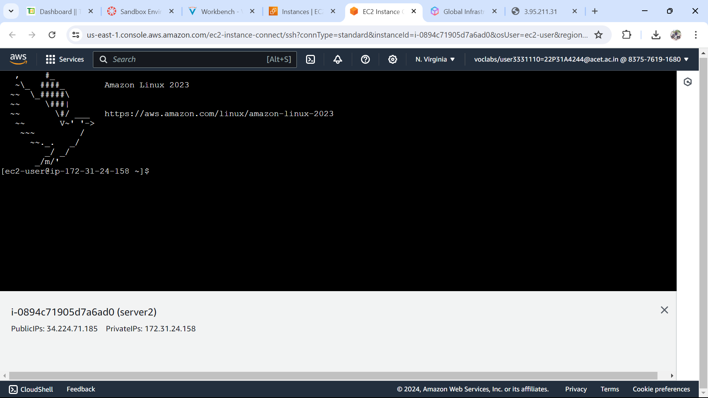

11.Delete the index.html file and transfer a sample web template of your choice to linux VM using SFTP and provide the screen shot of deployed webpage

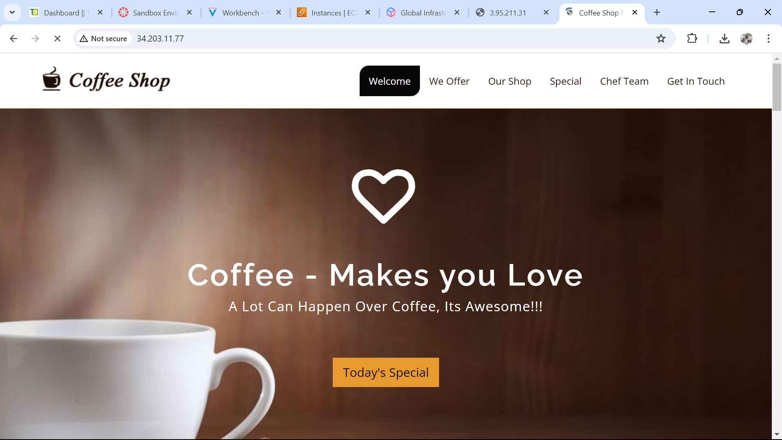

12.Protect the VMs from accidental shutdown and deletion

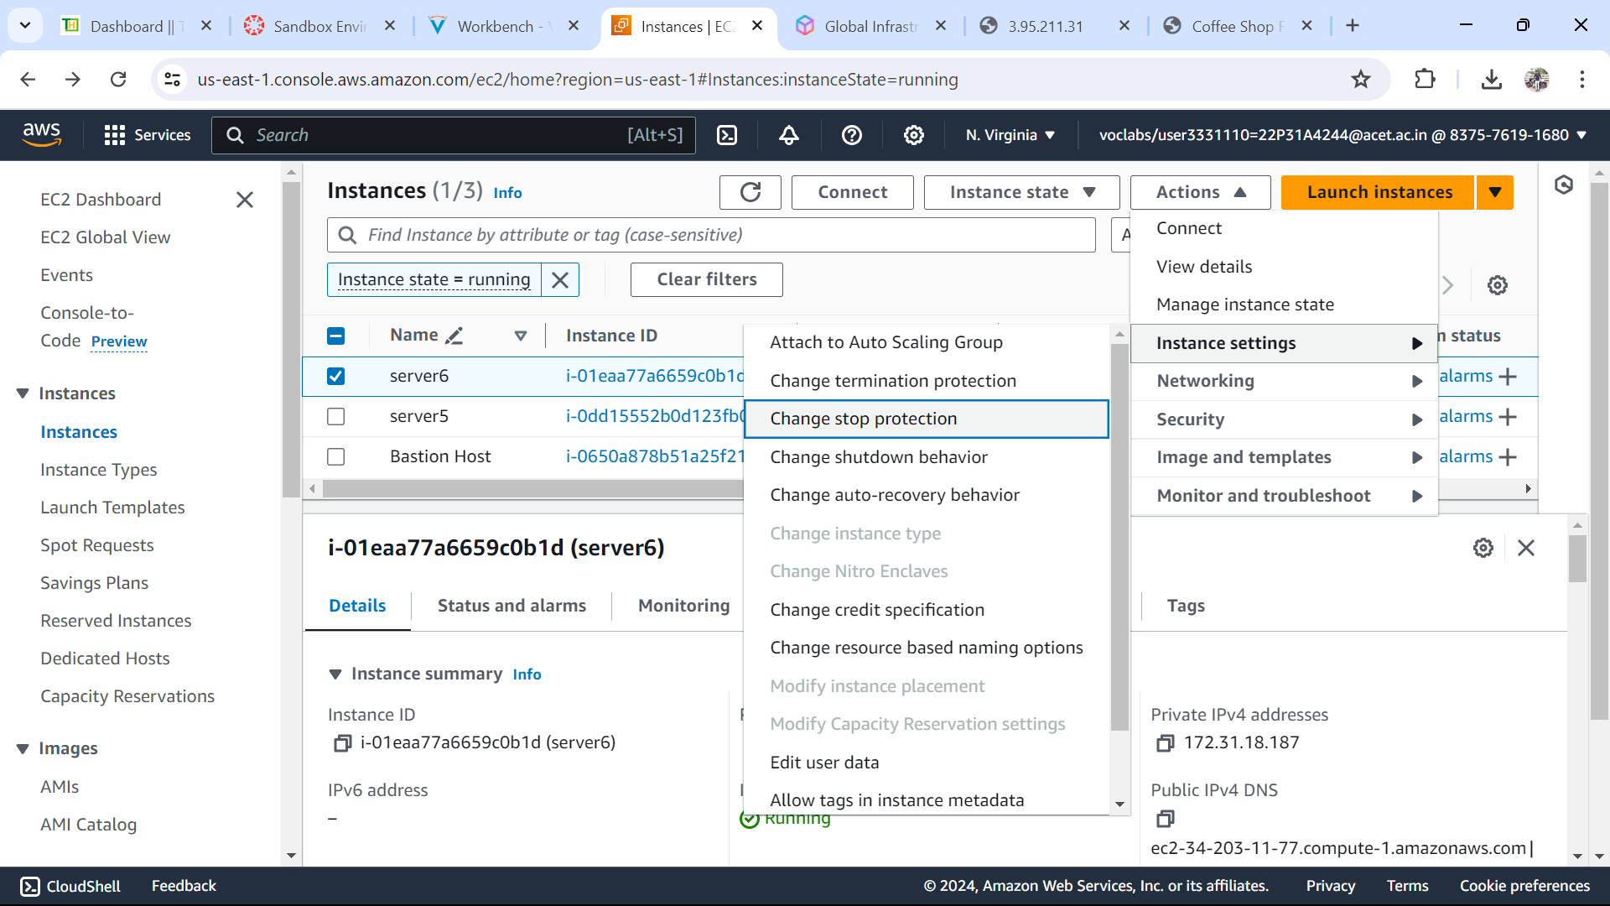

13.Configure the webserver in a way that even if you turn off and turn on again, the IP should not change

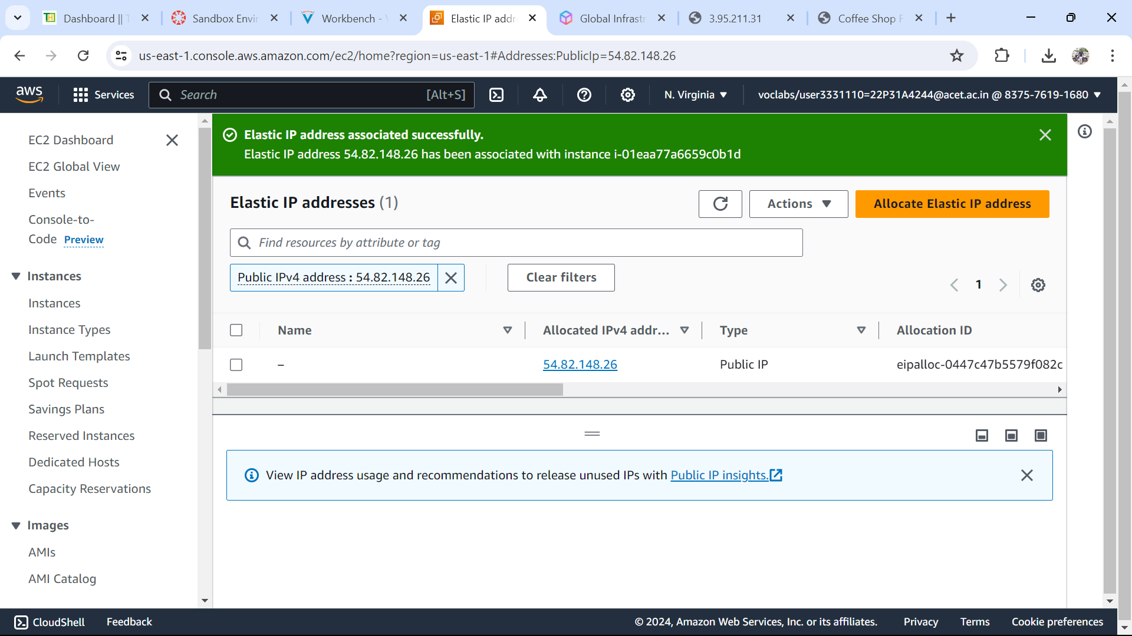

14.Provide the screen shots of following outputs:

* 1. Calendar of July 2024
  2. Time and date with one command
  3. Change the timestamp of a file
  4. Create 5 empty files with one command
  5. Edit any one file with vim and write one line of content and save, exit
  6. Use necessary command to write the second line into same file without replacing existing line
  7. Change the file permissions using numeric permissions format that users should have read-only permissions, group execute and others no permissions
  8. Create a user with your name and provide the screenshot of user id from user information file

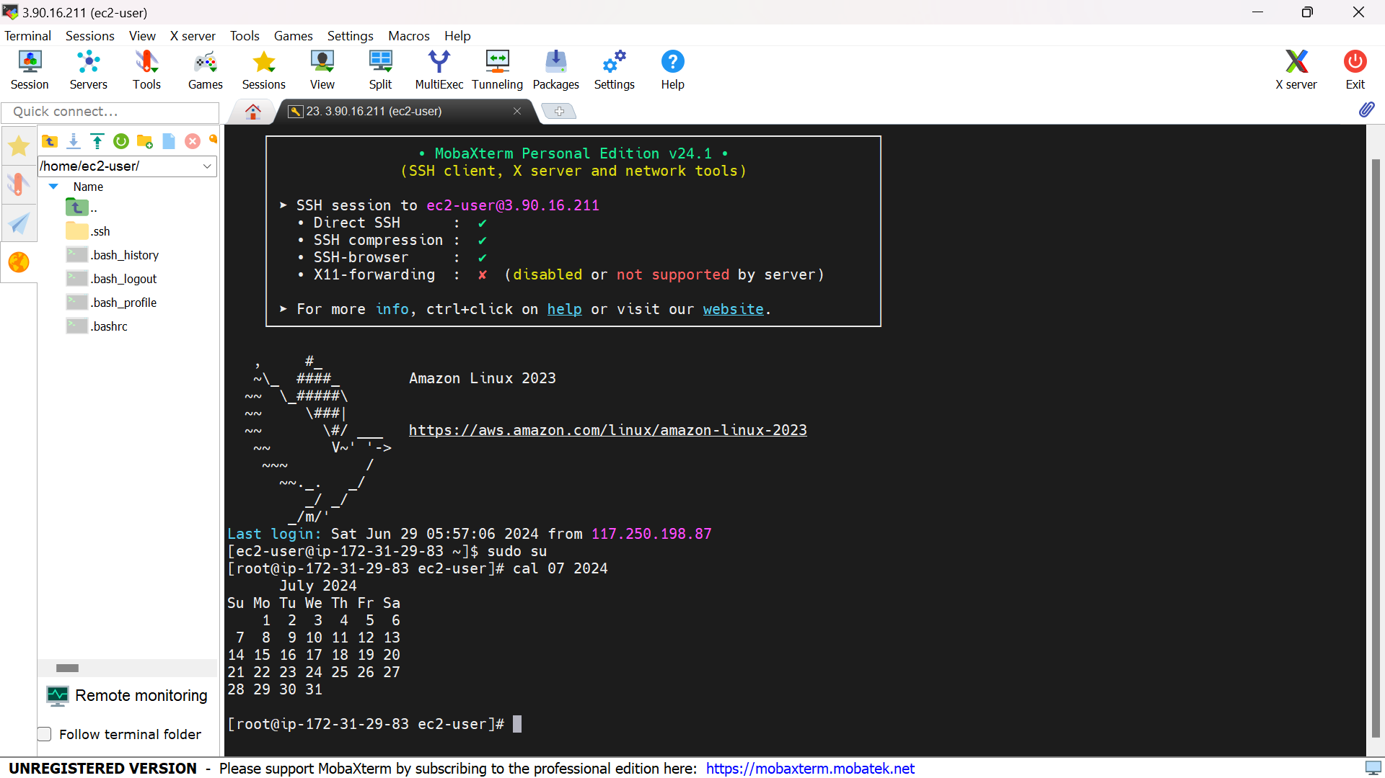

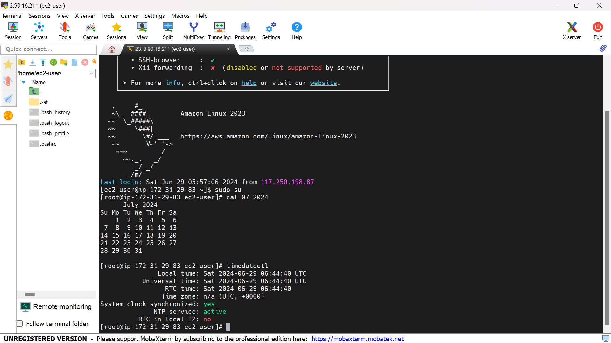

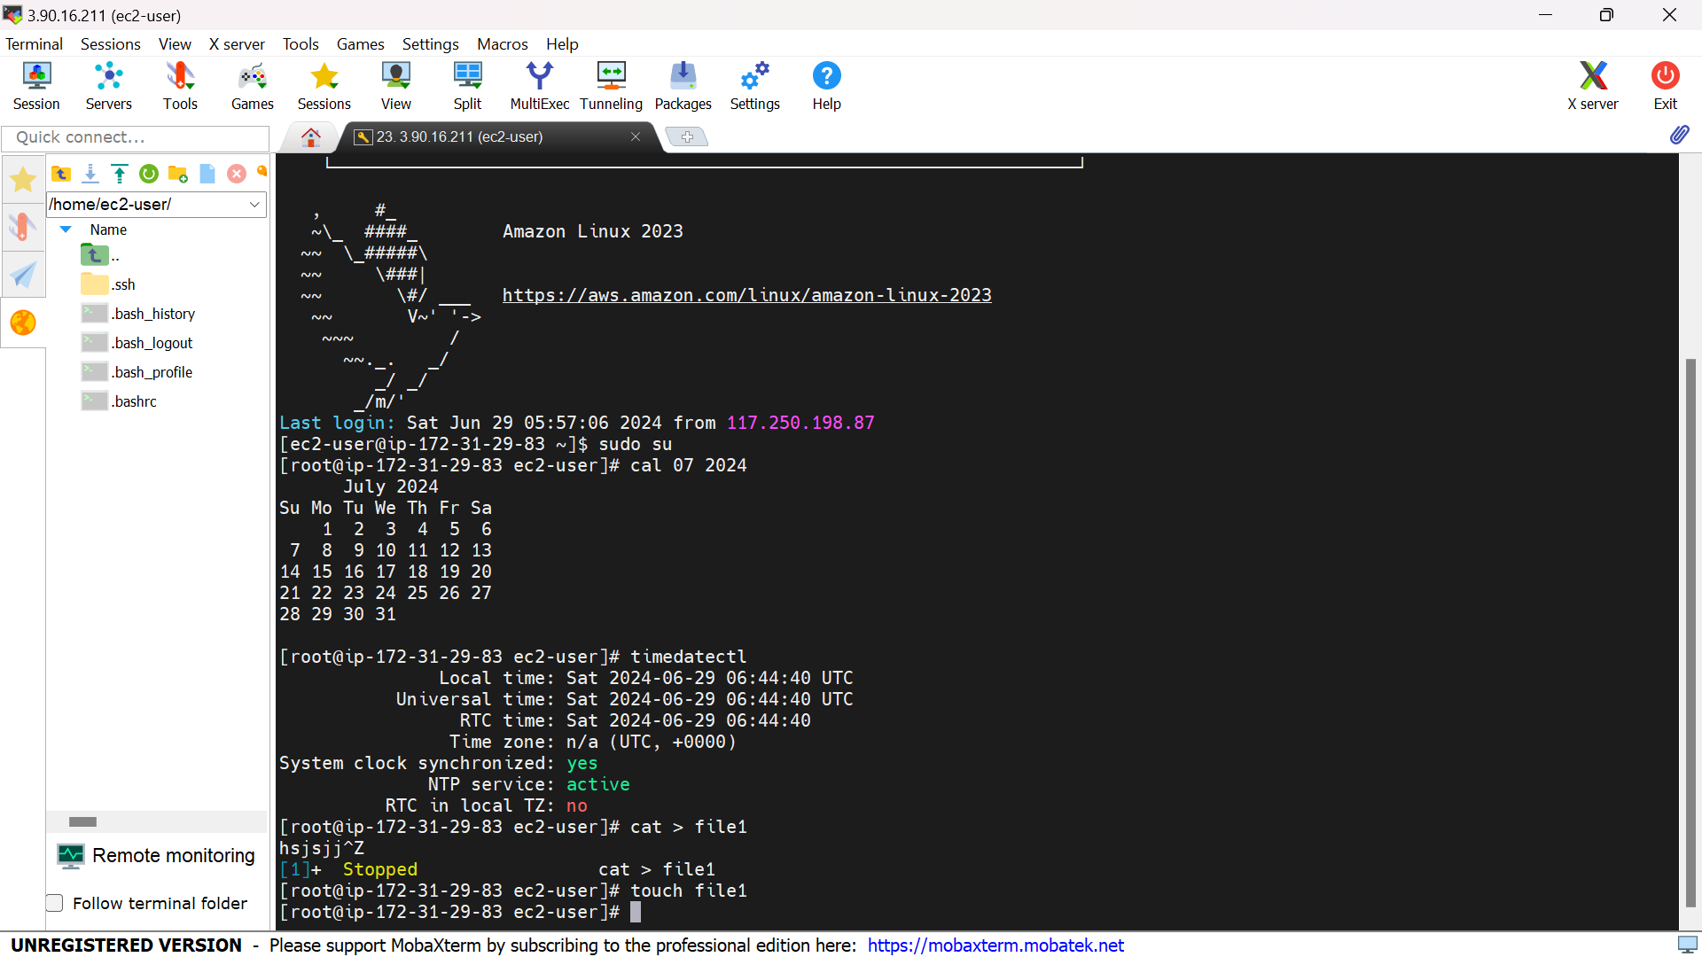

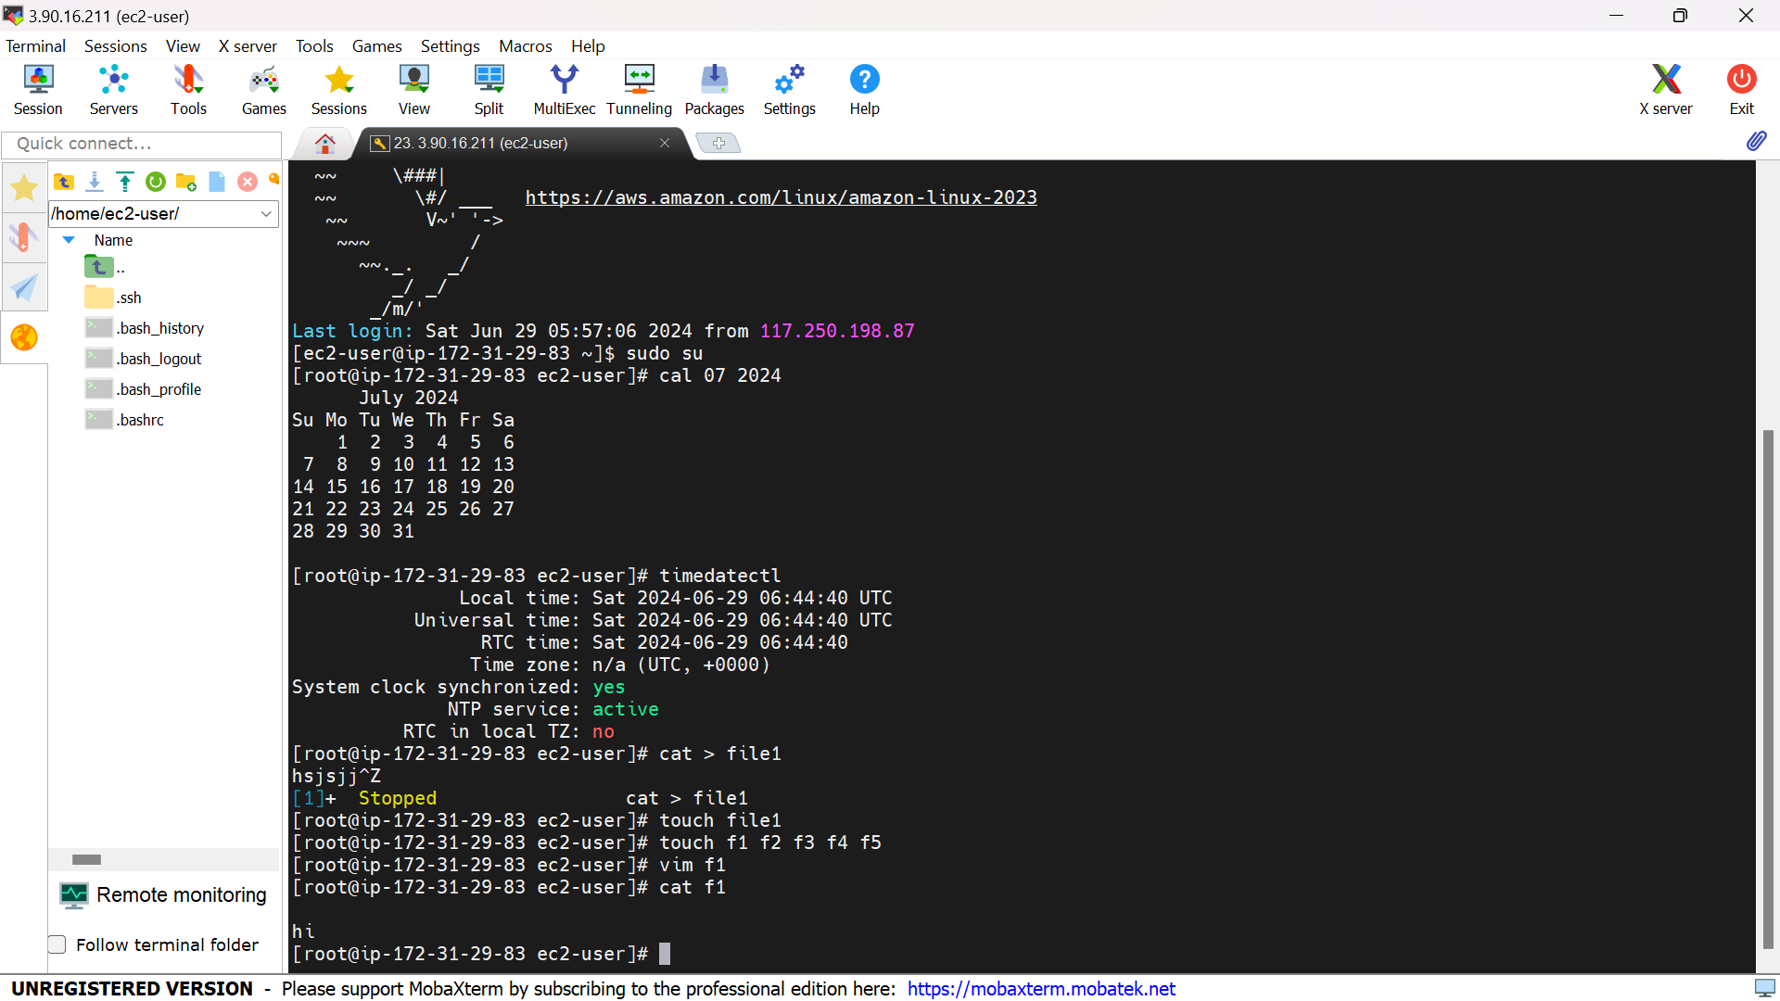

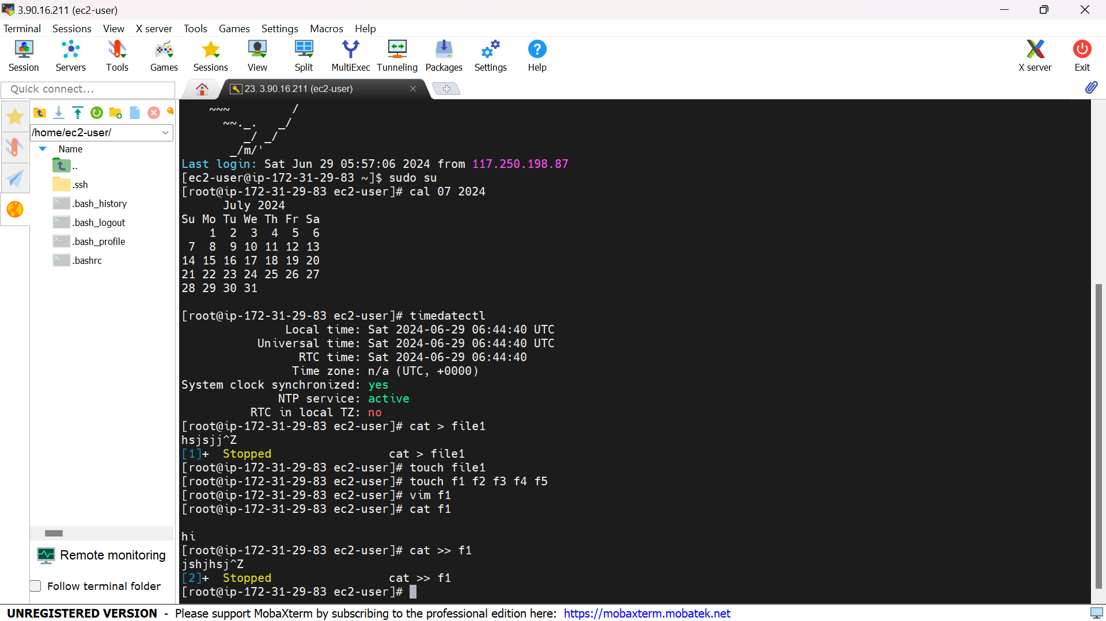

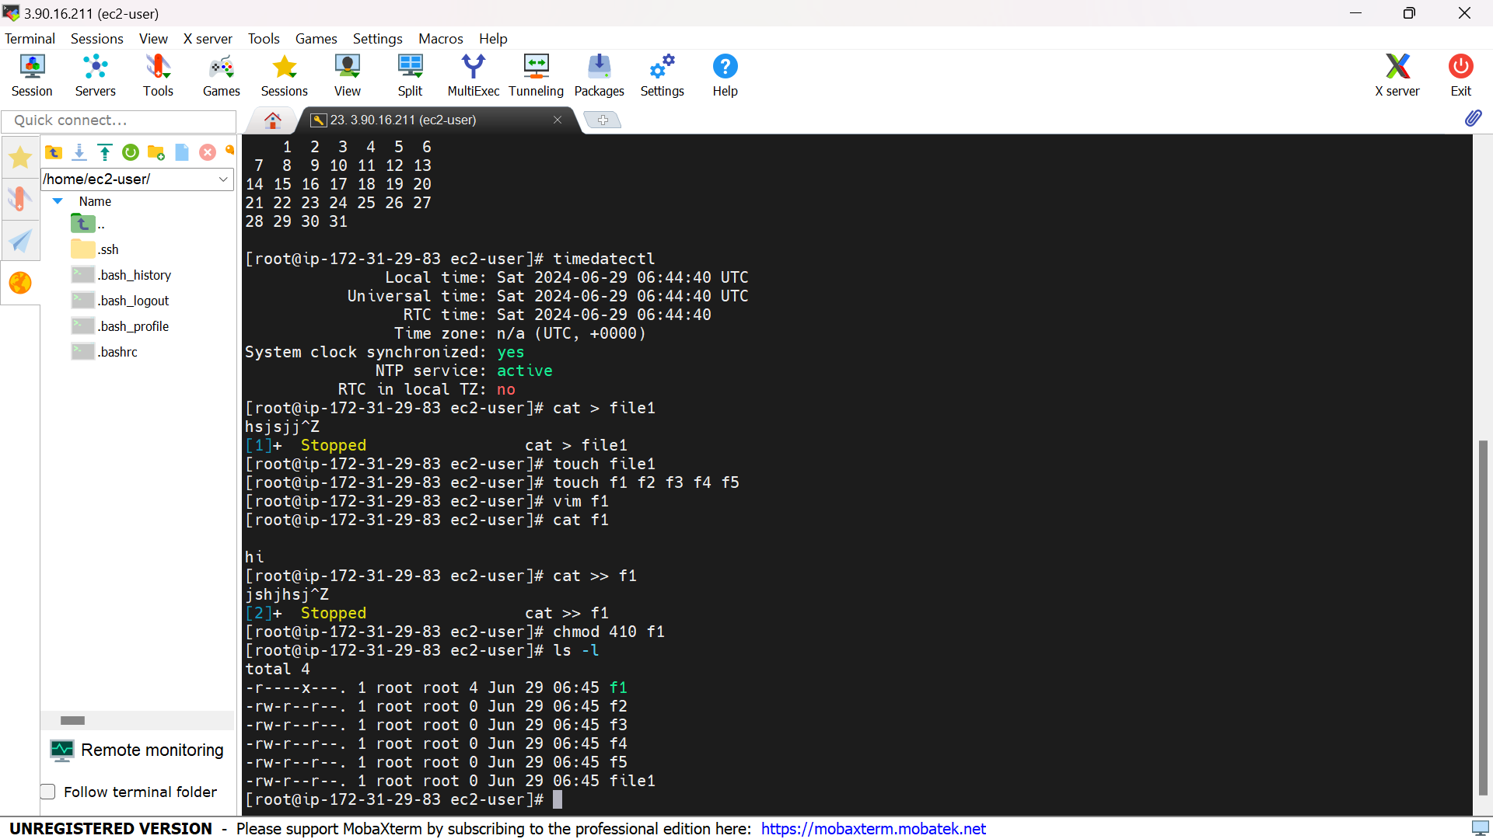

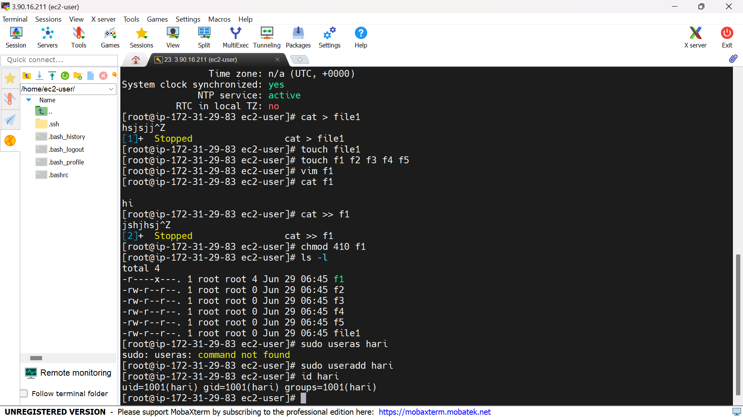

15.Launch the Windows server latest version and connect to it that should be able to copy a small sample file from your laptop to windows VM.

